* [the-cicada-puzzles.wikia.com/wiki/2014_Recruitment_Puzzle](http://the-cicada-puzzles.wikia.com/wiki/2014_Recruitment_Puzzle)

**cca 07:30 GMT 6th JAN 2014**

**The Beginning**

[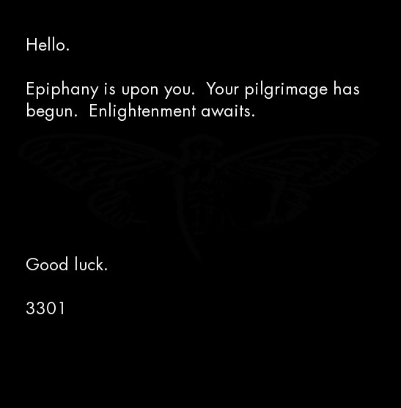](https://github.com/scream314/cicada3301/blob/master/assets/2014/stage01/zN4h51m.jpg)

Start with the tweet

wget https://twitter.com/1231507051321

Get the image

wget i.imgur.com/zN4h51m.jpg

Run outguess

outguess -r zN4h51m.jpg zN4h51m.jpg.outguess

Reading zN4h51m.jpg....

Extracting usable bits: 29835 bits

Steg retrieve: seed: 178, len: 1150

Verify signature

gpg < zN4h51m.jpg.outguess

Outguess:

-----BEGIN PGP SIGNED MESSAGE-----

Hash: SHA1

The work of a private man

who wished to transcend,

He trusted himself,

to produce from within.

1:2:3:1

3:3:13:5

45:5:2:3

20:3:20:5

8:3:8:6

48:5:14:2

21:13:4:1

25:1:7:4

15:9:3:4

1:1:16:3

4:3:3:1

8:3:26:4

47:3:3:5

3

13:2:5:4

1:4:16:4

.

o

n

i

o

n

Good luck.

3301

-----BEGIN PGP SIGNATURE-----

Version: GnuPG v1.4.11 (GNU/Linux)

iQIcBAEBAgAGBQJSyjguAAoJEBgfAeV6NQkPsgAP/A3tMC3lpyFNAc/sj+Izu15S

CzUjZJMe20Gu9UMNokQ2UJabktv9w0GMyK17TrMkUcU+ZpjdzGNqKoE2ETVxLmD/

uBZtR5PnF9EE3D08tJUPN1vSrYNkYk+9zcaUJZMPNgYNCt/CACutPwrOci9i9FDO

7BIpnhGqT3ZruqrSwO2Y73LJI1xxUt1XUqh1NQ+fJeAFMRkJBZZazkxRlgk3GGsF

fLrcEKrS+KBipV1EQaaKxjISc9hc2c1TfxE66evlkN+zLcoyDcYuyruNM5wiZzgM

2uR58c+xgWQgG5UuLFClfvjDxUvDkrKt4mzEeaYSUm1MsYueuYklz4ydlg5Mf6l2

p1WyAxO52XfXVUZASk6VmaEQ0WjODTXvLeFTxUSDoKDMkvxDVxX6wGkufS9JwakB

nTZizZ8Ypv8GcNCuNNGd6gZ1Vk2MYntggXdX8INd0Itcd3QnLqbBnATDOinDxlOs

5zTrtyTHNaxxDagPfAbU1jMXM0aHd7PFAzjjp7kgCTWqMyBch+8Vt80bjkdL9iw8

Q3hxuanq8mh6nUGc+tNe0UfqKHEbE+jWIezYqgawJB0M9R5OhxWE+E+jPXtZKkXQ

JHYndPDrrsV8q27b7p0KN0+oblTkjqsItIAuLu7FNd0B4xb1jjp1Sbh7WJdZ/rbi

mCO0vN/obU9qK1Vfapy0

=6Gxk

-----END PGP SIGNATURE-----

**The Book Cipher**

The riddle leads to the book Self-Reliance by Ralph Waldo Emerson (<https://math.dartmouth.edu/~doyle/docs/self/self.pdf>).

Applying the book code (paragraph:sentence:word:letter) yields: auqgnxjtvdbll3pv.onion

**The First Onion - auqgnxjtvdbll3pv.onion**

Get onion data

wget http://auqgnxjtvdbll3pv.onion

Get the image

wget http://auqgnxjtvdbll3pv.onion/1033.jpg

Run outguess

outguess -r 1033.jpg 1033.jpg.outguess

Verify signature

gpg < 1033.jpg.outguess

index.html:

<html><head><title>For Every Thing That Lives Is Holy</title><body><img src="1033.jpg" /></body></html>

Outguess of 1033.jpg:

-----BEGIN PGP SIGNED MESSAGE-----

Hash: SHA1

Welcome.

Good luck.

3301

e = 65537

n = 75579125746085351644267182920580212556413102071876330957950694457000592\

10248050757270234679993673844203148013173091173786572116639

- -----BEGIN COMPRESSED RSA ENCRYPTED MESSAGE-----

Version: 1.99

Scheme: Crypt::RSA::ES::OAEP

eJwBswBM/zEwADE2MgBDeXBoZXJ0ZXh0LE2jxJS1EzMc80kOK+hra1GKnXgQKQgVitIy8NgA7kxn

2u8jNQDvlu0uymNNiu6XVCCn66axGH0IZ9w4Af3K/yRgjObsfA1Q7QqpXNALJ9FFPgYl5rh07cBP

M9kbSH6DynU/5cYgQod2KymjWcIvKx3FkjV4UOGakDnBf1eQp1uwvn3KxDVwTyzPqbMnZvOA06Ec

AfKtyz1hEK/UBXkeMeVrnV5SQQ==

=yTUshDMKN65aPaKAR0OU8g==

- -----END COMPRESSED RSA ENCRYPTED MESSAGE-----

-----BEGIN PGP SIGNATURE-----

Version: GnuPG v1.4.11 (GNU/Linux)

iQIcBAEBAgAGBQJSyly/AAoJEBgfAeV6NQkPHhUP/R7nuYiTMw+3sbe0xV+4rmiN

liSDmW6ibOK4UTkZDTeAS5kAKIjxCC3DwWi0lXqBGZyabojWHM2wRwYLOhvfKvgg

DgPnW1BSZ/R67GaUy0CM/vtZOtktBeIdntlZamk9DpW5bQ311c7N9dy6uWc8+hOM

umkcnT7u799zESazFgCeDSOw0cFgHDiG9UTAQxbe+NsXY/NKm4N0WAtgWmdte5ym

dU8ImpmXWg8NChdn49UtuAACi8s8tcI/lHj1Yjh+AQRbO2+Ozn9eSxUAQ1TsXSgt

30jKmXI5ss4WHS16nYsS97BUbo4oX3NBXaCjSZb7fKO9CRJBo3gm2R8/NcIMIkEc

GlQ/7rCQWHXA0MC+415ut5dcJf2ihwid81c1xsDyqQdfhEsWE/wVnK7Ujje+BgcO

ybBHl8ejJzWhZkCvesHOmIo1RLEanxlGUC5jcRLqImrT7A9CrO+EVFW16EZpvzug

Tsopo56+JbIFiIzAq+CGujHgDZnoHJFtB574utjOnZz9xzsVZ3lirQyAFOGauH+g

K+XxjXjY8tT5lppAgmF3zWKqha7NoV+9FgFl2q2SS9ue+s4Joyn5PYKnICJeze3i

K9BZ7gIT694s4dLEzu6kGaRyuNmx8qaoDs0kjvEB5pI+1buGuNAysHQWIDyY3DWb

CjJ1AnBLY0ObxaMbWMR/

=d5E8

-----END PGP SIGNATURE-----

After decrypting the RSA encryption decrypt RSA the Tor adderss cu343l33nqaekrnw.onion was found.

**The Second Onion - cu343l33nqaekrnw.onion**

Upon visiting the service, the following document was displayed:

<!--Patience is a virtue-->



The page appeared to be static. However, after some time, we noticed that the string was slowly growing. Every few minutes, two characters were appended to the end of the string. This process continued for approximately 23 hours. The time intervals between new bytes were found to be multiples of five. Various users recorded the minutes between updates, the time that they occurred, and the data appended at those times.  
After 23 hours, the process stopped and no more characters/bytes were appended to the string.  
  
However, about an hour after the string finished growing, at approximately 05:31:40 GMT the document changed. The old 512-character code was gone, along with the HTML comment. In its place was the following document:

https://github.com/micheloosterhof/cicada-2014/blob/master/stage03/cu343l33nqaekrnw.onion/index.html.2

Note that the HTML comment was changed from

<!--Patience is a virtue-->

to

<!--761-->

We noticed that, by applying the Gematrius Primus from the 2013 puzzle to the phrase 'Patience is a virtue' and summing the result, one obtains 761. The number is also a palindromic prime.  
  
The new string was 3641299 (?) characters long. We noticed that it contained a significant amount of repeated text.  
  
Analsysis of this new string revealed that it contained three JPEG image files. This was discovered when we:

* Converted the string into its binary representation
* Flipped all the bits (i.e. 0 becomes 1, 1 becomes 0) [Note: this is equivalent to XOR 111111] Looking at that XOR'd binary string, we noticed that the first two bytes were

0xFF 0xD8

Wikipedia tells us that these are the first two bytes of a JPEG image.

torify wget http://cu343l33nqaekrnw.onion/

Final file in index.html.2

hex dump and XOR with 0xFF

dd if=onioninvert.bin of=onion1.jpg bs=1 skip=0 count=168876

dd if=onioninvert.bin of=onion2.jpg bs=1 skip=168876 count=1476614

dd if=onioninvert.bin of=onion3rev.jpg bs=1 skip=1645490 count=175159

rev < onion3rev.jpg > onion3.jpg

cat index.html.2 | tail -n +2 | xxd -r -p > out

outguess -r onion1.jpg onion1.outguess

outguess -r onion2.jpg onion2.outguess

outguess -r onion3.jpg onion3.outguess

gpg < onion1.outguess | xxd -r -p > onion1.bin

gpg < onion2.outguess | xxd -r -p > onion2.bin

gpg < onion3.outguess | xxd -r -p > onion3.bin

XOR all the three files together

make xor

./xor -o xor.txt onion1.bin onion2.bin onion1xor2.bin

gpg < xor.txt

The XORing produces:

-----BEGIN PGP SIGNED MESSAGE-----

Hash: SHA1

IDGTK UMLOO ARWOE RTHIS UTETL HUTIA TSLLO

UIMNI TELNJ 7TFYV OIUAU SNOCO 5JI4M EODZZ

Good luck.

3301

-----BEGIN PGP SIGNATURE-----

Version: GnuPG v1.4.11 (GNU/Linux)

iQIcBAEBAgAGBQJSy23PAAoJEBgfAeV6NQkPeJwP/0IoafJ1SbmhD+KNbL5I2EdH

jgPRnZNrKCyMpWFSIw1qs6ujuw6VnW/rfnOD+df4kpzoAwEFfZDcRnBVsvIzOJ31

Txj9jXD22ki/CNRY88NyIzW9fjKs+iOylsa7Tx+6PBb3ndoYNEwnQwLIq3K4S3kQ

tgMzE3LiVq2pQwqFNdN+zGqcq7POEs0GmnL1aNpqU+Wrba4gSfoWwQBWUDv3S/s8

vY0hEqhWNd76wphig6hH6OyIaX/t1eYfcsSYhzAE5oKKahGr1E7cX1GBpHCIr1WM

ZwNaGVArQAkyEzT++tmF01O9h218CiTUFoBM/Zxyra7vxI2UOYS/pLonuV+eXARY

YfPHaZZxfk3bUWXcxioRukFSY2+xNdPfuBIT8rcJqa1kPJOzeZVC/IcwHA2mmG4l

3ltiVcDnQrZgz6Im3/ugFg8bqW12qqZ6XizRP3EXm4EnyhpfKZnXKPLEOvPKCj6j

1kYCrLmGtTTPFx79fZfryGXQIEAmipRbjVS5sVbUCfgmqUagmdU6v9VI53n6+r0J

b2amxREA+2MflkEoVJUaLQJ1rKZLFFJ9J17zUaXKMllsDBWXJS4Mb54o2+8bkEcM

3cP+16XV9pf2wZBkJE0AwoXI4L8JEyjNZZcGSLy8BojlAupX3Fg9KKt71XXrm9FD

tuBhMYWo/TDz+4UzLB+I

=57tj

-----END PGP SIGNATURE-----

This ciphertext had been created using a simple column transposition cipher (<http://tholman.com/other/transposition/>).  
By arranging the ciphertext into 14 columns like so:

0 1 2 3 4 5 6 7 8 9 10 11 12 13

I D G T K U M L O O A R W O

E R T H I S U T E T L H U T

I A T S L L O U I M N I T E

L N J 7 T F Y V O I U A U S

N O C O 5 J I 4 M E O D Z Z

And reordering the columns like so:

2 8 9 1 12 13 11 4 5 7 3 0 6 10

G O O D W O R K U L T I M A

T E T R U T H I S T H E U L

T I M A T E I L L U S I O N

J O I N U S A T F V 7 L Y U

C M E O Z Z D 5 J 4 O N I O

A message is obtained:

GOOD WORK

ULTIMATE TRUTH IS THE ULTIMATE ILLUSION

JOIN US AT FV7LYUCMEOZZD5J4ONIO

Assuming that the final N was omitted in order to fit the bounds of the column transposition cipher, and applying proper formatting, the following Tor hidden service address is obtained: fv7lyucmeozzd5j4.onion

**The Third Onion - fv7lyucmeozzd5j4.onion - li676-224.members.linode.com**

The first visitor to this hidden service was greeted with a blank page. The page remained blank for a short time and then changed to the following document:

<!--1033-->

87de5b7fa2

The string slowly grew over time, with two new characters (one byte) being added at widely varying intervals.  
Final index.html:

<!--1033-->



In the meantime, a solver ran the tool '''not''' DirBuster but maybe Nessus against the hidden service and discovered an apparent misconfiguration of the backend Apache server. The server was leaking a system status page. "Whether this was intentional is unknown. However, shortly after the page was discovered, it appears that Cicada was alerted that the status page had been discovered because the content of that page changed." ('''source?'''))

[**Server status original**](https://github.com/scream314/cicada3301/blob/master/assets/2014/li676-224_server-status_orig.txt)

[**Server status new**](https://github.com/scream314/cicada3301/blob/master/assets/2014/li676-224_server-status_new.txt)

Interesting parts:

##

<dt>Current Time: Thursday, 06-Jan-2014 00:13:17 UTC</dt> # these should not

<dt>Restart Time: Tuesday, 06-Jan-2014 00:13:17 UTC</dt> # be equal...

<dt>Parent Server Generation: 2</dt> # (means: Number of times you have instructed apache to re-read its configuration file and gracefully restart all child processes. )

<dt>Server uptime: 1 days 0 hours 33 minutes 14 seconds</dt> # 1d0h33m 14s

<dt>Total accesses: 931377 - Total Traffic: 7.2 GB</dt> # the whole index is about 3MB?

<dt>CPU Usage: u50.58 s65.25 cu0 cs0 - .0333% CPU load</dt>

<dt>5.09 requests/sec - 37.6 kB/second - 7.4 kB/request</dt>

<dt>10 requests currently being processed, 40 idle workers</dt>

Appended to the end of the server status was yet another very long string. This string was found to contain two image files in a similar ordering as the RSA onion, except that there was some data between them (OOB or Out Of Bounds data):

[0xFF 0xD8..............................] [Data in between JPGs] [..............................0xD8 0xFF]

After building the first JPG from the hex:

xxd -p -r < server-status.hex > server-status.jpg

One obtains the image [[Liber_Primus#05.jpg|05.jpg]]. Doing the same for the reversed copy of the second JPG yields the same image as the first, except for that OOB data.  
  
Comparing the first and second images

cmp -l server-status.jpg rev.server-status.jpg

one obtains the OOB data:

a02373230202020202833313020202020213433302020202021333130202020202135313a06363

330202020202939313020202020203331302020202020323330202020202028313a06323230202

020202534323020202020202139302020202025343230202020202632323a08313020202020203

2333020202020203331302020202029393130202020202636333a0135313020202020213331302

02020202134333020202020283331302020202022373230a0a

Note that all of these bytes are within the printable range of ASCII characters, and many of them appear to be ASCII for digits (e.g. 0x30, 0x39).  
  
Converting this string to binary:

xxd -b oob.hex oob.bin

and reversing that:

xxd -r oob.bin oob-rev.bin

we obtain:

272 138 341 131 151

366 199 130 320 18

226 245 91 245 226

18 320 130 199 366

151 131 341 138 272

Among other things, this is a magic square whose magic number is -- you guessed it -- 1033.  
Here's a nice one-liner to get that matrix from the original image:

dd if=server-status.jpg bs=1 skip=$((0x00521e4)) count=357 status=noxfer | rev | xxd -p -r

[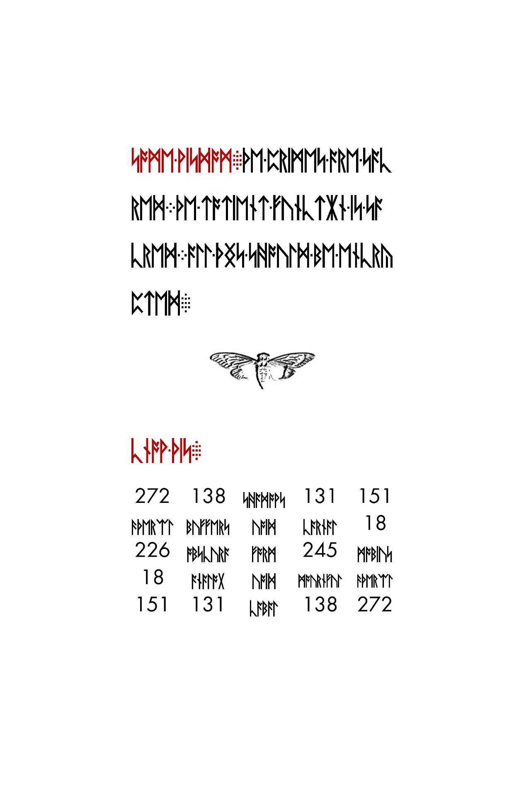](https://github.com/scream314/cicada3301/blob/master/assets/2014/stage04/server-status.jpg)

About a day went by with little activity other than speculation on the meaning of this matrix. Then the string from the main page stopped growing. According the the HTTP header, the final update occurred on January 11 at 01:09:01 GMT. The final document was:

<!--1033-->



The final string was 512 characters (assuming hex, 256 bytes or equivalently 2048 bits). It was observed that this string matched the growing string from the previous onion.  
  
On January 11 at 10:07 UTC, the Apache server status page changed once again to display a new hexadecimal string:

TODO: missing

This string contained the following two images ([[Liber_Primus#03.jpg|03.jpg]] and [[Liber_Primus#04.jpg|04.jpg]]) in the same style as before

[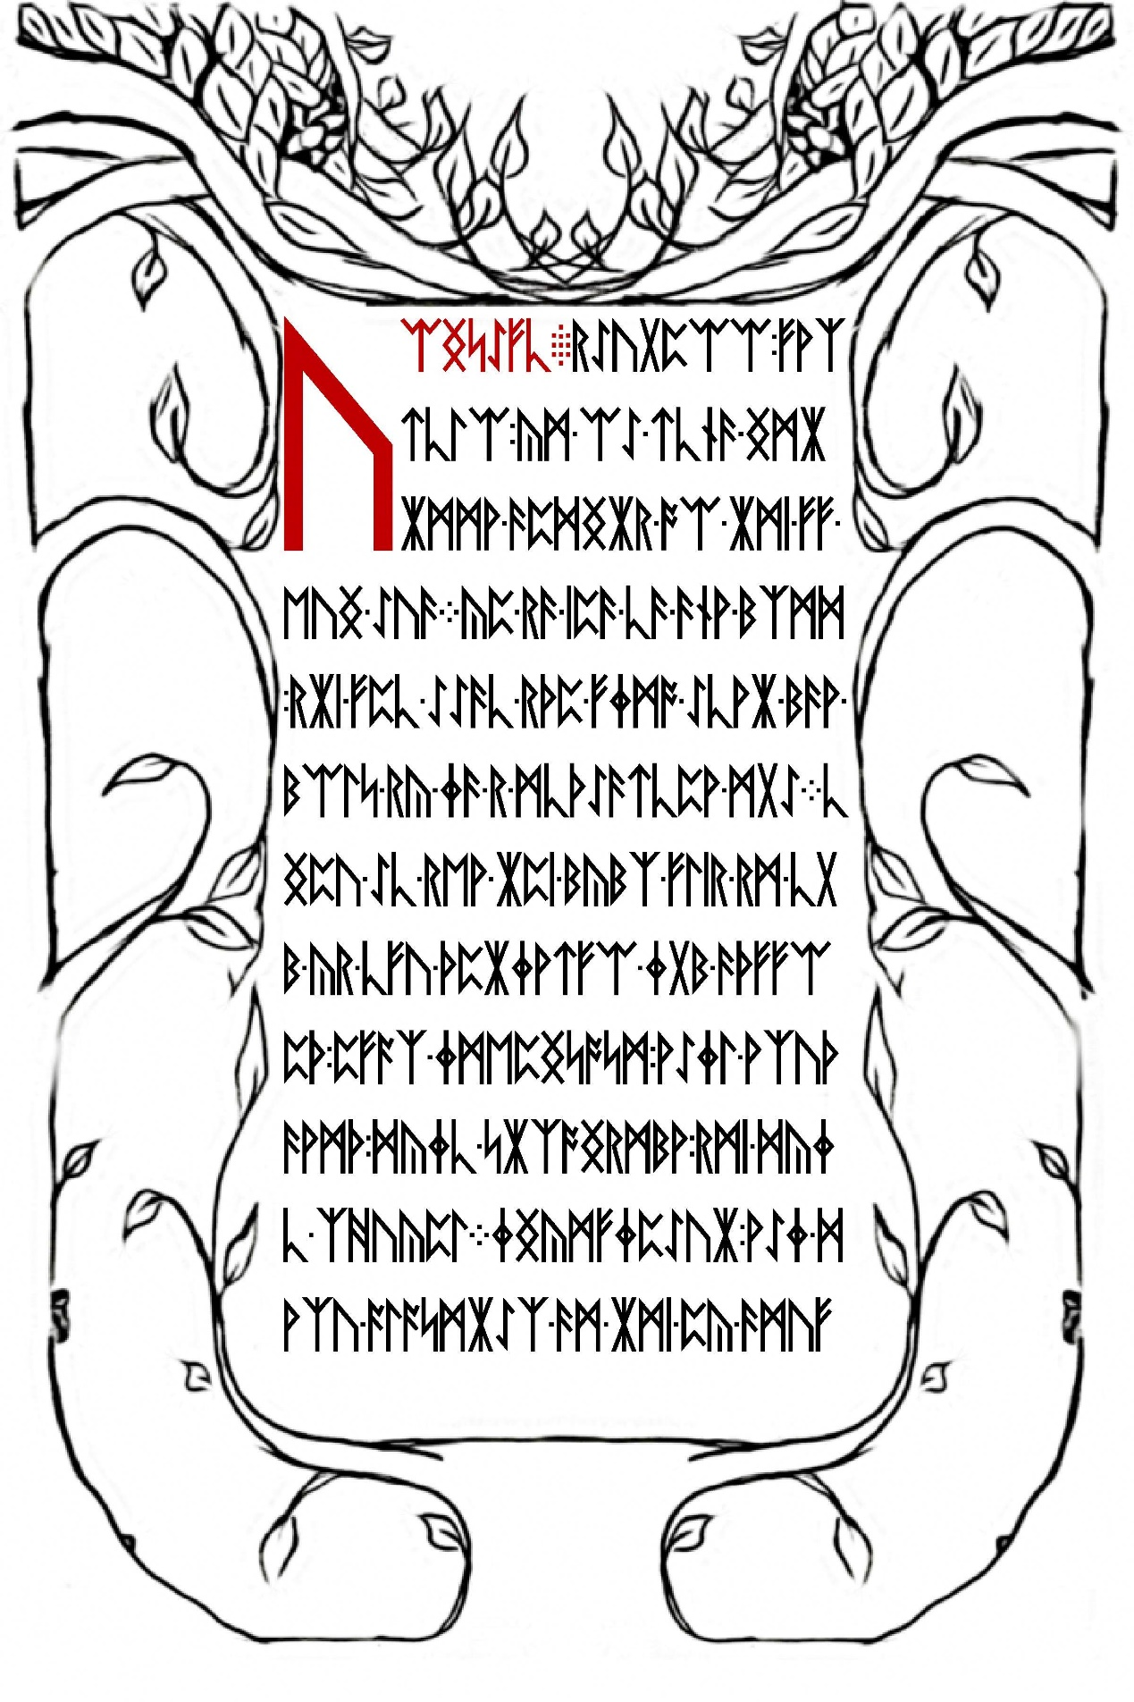](https://github.com/scream314/cicada3301/blob/master/assets/2014/stage04/index.1.jpg)

[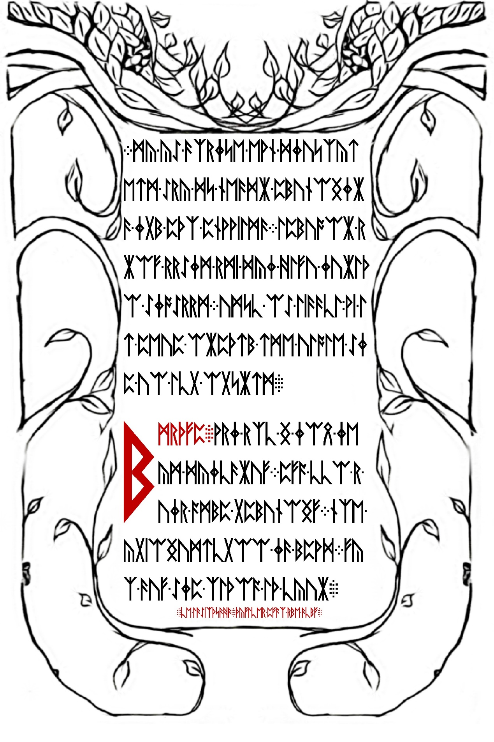](https://github.com/scream314/cicada3301/blob/master/assets/2014/stage04/index.1.rev.jpg)

[0xFF 0xD8...............] [...............0xD8 0xFF]

The hex string from the outguess of [[Liber_Primus#03.jpg|03.jpg]] encodes a JPG image. (TODO: insert image)  
The runes on the image were encoded with a Vignere cipher. Using the key

welcome pilgrim to the

we obtained the Vignere offsets

22, 11, 9, 24, 26, 10, 11, 16, 19, 9, 23, 25, 19, 10, 13, 26, 27, 11

and using these offsets to decode the original runetext we obtained

A U O W Y F X L 5 L C S F J 3 N O N IA N

which formatted as a hidden service address yields: [[Cicada#The_Fourth_Onion_-_avowyfgl5lkzfj3n.onion|avowyfgl5lkzfj3n.onion]]

**The Fourth Onion - avowyfgl5lkzfj3n.onion**

Upon visiting the fourth onion we were greeted with the following document (yes, the opening html tag and the head are missing):

</head><body><!--3301-->



<hr>

<address>Apache Server at 127.0.0.1 Port 5243</address>

</body>

</html>

This string is 512 characters (256 bytes). Shortly after the discovery of this string the onion went offline until January 29 at 00:05 GMT, when it came back online. This time it contained no HTML. The sole content of the page was a signed message. The content of the message was a hex string (with newlines):

TODO: missing

This string began with the bytes

0x1F 0x8B

indicating the string was a gzip file. Converting to binary

xxd -p -r onion4.hex onion4.gz

using file to confirm type

$ file onion4.gz

onion4.gz: gzip compressed data, was "data.out", from Unix, last modified: Fri Jan 24 15:10:12 2014

and unzipping

gzip -d onion4.gz

we are left with binary data containing four images 06.jpg-09.jpg.  
  
The text in the outguess of [[Liber_Primus#08.jpg|08.jpg]] was found to be encoded with a columnar transposition cipher. Period = 7, key = 1736254.  
Cleartext:

TOBELIEVETRUTHISTODESTROYPOSSIBILITYQ4UTGDI2N4M4UIM59133

Which of course translates to

TO BELIEVE TRUTH IS TO DESTROY POSSIBILITY Q4UTGDI2N4M4UIM59133

Formatting that last bit as an onion URL yields q4utgdi2n4m4uim59133.onion.

**The Fifth Onion - q4utgdi2n4m4uim59133.onion**

The fifth onion contained the following (signed) message:

Very long. Check:

https://raw.githubusercontent.com/micheloosterhof/cicada-2014/master/stage07/q4utgdi2n4m4uim5.onion/index.html

Shortly afterwards it went offline.  
  
Converting the hex string to binary

xxd -p -r onion5.hex onion5.bin

and checking with file

file onion5.bin

tells us that it is an mp3 file. Renaming as such

mv onion5.bin onion5.mp3

and reading the ID3 tags

id3v2 -l onion5.mp3

shows

id3v2 tag info for his5u.mp3:

TIT2 (Title/songname/content description): Interconnectedness

TPE1 (Lead performer(s)/Soloist(s)): 3301

his5u.mp3: No ID3v1 tag

Translating each character of the word 'Interconnectedness' to its corresponding numerical value with the Gematria Primus 2013 and summing yields 772 (a prime). The song itself is 277.133 seconds long.  
  
On January 31, Onion 5 came back online. This time it contained an image:

http://vignette1.wikia.nocookie.net/the-cicada-puzzles/images/7/7d/Onion5portrait.jpg

This painting is Portrait of Andrés del Peral by Goya y Lucientes. The significance of this is indeterminate.  
A subimposed image of a man can be seen in the upper right corner. Adjusting image filters reveals hidden information:

http://vignette2.wikia.nocookie.net/uncovering-cicada/images/f/f5/Img_diff.jpg

http://vignette4.wikia.nocookie.net/uncovering-cicada/images/2/26/Img_diff2.jpg

cicada

logo

Rasputin

181

7

15

16 966

456 1071

351 626

7 204

434

= =

1033 3301

The man in the upper right is supposed to be Grigori Rasputin. The significance of this is indeterminate. The significance of these numbers is indeterminate.  
Applying outguess to the original portrait

outguess -r onion5portrait.jpg onion5portrait.outguess

and checking the output with file

file onion5portrait.outguess

indicates that the retrieved data is a bzip compressed file. Decompressing

bzip2 -d onion5portrait.outguess

gives us a text file with a signed message:

Quite long. Check:

https://github.com/micheloosterhof/cicada-2014/blob/master/stage08/index

chop op 3 binaries into index.[123]

xxd -r -p < index.1 > index.1.jpg

xxd -r -p < index.2 > index.2.jpg

xxd -r -p < index.3 > index.3.mp3

This yields 2 JPG images and an MP3 file.

TODO: insert images

The equation in the first image is part of the Godel incompleteness theorem. The mp3 file is a segment of Bach's Trio Sonata in G Major (BWV 1039). The picture of the eye is a painting by M.C. Escher called 'Eye', painted in 1946.  
Gödel + Escher + Bach -> Gödel, Escher, Bach: An Eternal Golden Braid by Douglas Hofstadter  
The last bit of the signed message

3PI:6:1:3

LML:1:1:1

3

ETOATS:19:9:1

...AF:5:3:1

AMO:13:10:1

CC:8:6:1

CBIA:3:7:2

CFAF:5:23:6

SPR:1:8:1

7

C[1]:4:5:3

AWDV:6:2:1

C[2]:2:17:5

SC:3:17:1

AOGS:2:8:1

ONION

is a book code.  
  
The format of the code is

<chapter>:<line>:<word>:<letter>

Applying the code to the book:

3PI:6:1:3 Three-Part Invention 29 (u)

LML:1:1:1 Little Harmonic Labyrinth 103 (t)

3 (3)

ETOATS:19:9:1 Edifying Thoughts of a Tobacco Smoker 480 (q)

...AF:5:3:1 ... Ant Fugue 311 (t)

AMO:13:10:1 Introduction: A Musico-Logical Offering 3 (z)

CC:8:6:1 Crab Canon 199 (b)

CBIA:3:7:2 Canon by Intervallic Augmentation 153 (r)

CFAF:5:23:6 Chromatic Fantasy, And Feud 177 (v)

SPR:1:8:1 Six-Part Ricercar 720 (s)

7 (7)

C[1]:4:5:3 Contracrostipunctus 75 (d)

AWDV:6:2:1 Aria with Diverse Variations 391 (t)

C[2]:2:17:5 Contrafactus 633 (v)

SC:3:17:1 Sloth Canon 681 (z)

AOGS:2:8:1 Air on G's String 431 (p)

ONION

yields

ut3qtzbrvs7dtvzpONION

and formatting correctly yields: ut3qtzbrvs7dtvzp.onion.

**The Sixth Onion - ut3qtzbrvs7dtvzp.onion**

The first thing found at this onion address was a large block of hex after the HTML comment. It contained four JPEG images in sequential, non-reversed order (10.jpg-13.jpg).  
  
Get the latest files

torify wget http://ut3qtzbrvs7dtvzp.onion

Strip the headers and reverse hexdump

tail -n +2 index.html | xxd -r -p > index.bin

Extract four JPEG files

dd if=index.bin of=index.1.jpg bs=1 skip=0 count=754662

dd if=index.bin of=index.2.jpg bs=1 skip=754662 count=712733

dd if=index.bin of=index.3.jpg bs=1 skip=1467395 count=703428

dd if=index.bin of=index.4.jpg bs=1 skip=2170823

Run outguesson each

outguess -r index.1.jpg index.1.outguess

outguess -r index.2.jpg index.2.outguess

outguess -r index.3.jpg index.3.outguess

outguess -r index.4.jpg index.4.outguess

Verify signature

gpgv < index.1.outguess

gpgv < index.2.outguess

gpgv < index.3.outguess

gpgv < index.4.outguess

The onion went offline shortly afterwards. Six days later it came back online, sporting the following message:

-----BEGIN PGP SIGNED MESSAGE-----

Hash: SHA1

Hello. You have done well to come this far.

Please paste the magic squares into the appropriate textareas below, then

provide the URL to your Tor hidden service.

The path to your CGI script which accepts uploads should be '/cgi-bin/upload'

and the HTML form input which accepts file uploads should be named 'file'.

Additionally, please generate a GnuPG key pair, and place the public key

in the location '/key.asc'.

We will contact you soon.

Good luck.

3301

-----BEGIN PGP SIGNATURE-----

Version: GnuPG v1.4.11 (GNU/Linux)

iQIcBAEBAgAGBQJS43VRAAoJEBgfAeV6NQkPVcQP/Rnli3AdTLAj28W1SMHTD6v0

Q67n89uGF6ZeD4U+dD2FHULAL9upNBRdzF7golqcfJCpeIKN0JYyilpGgSyTQmx+

yJXinlq4ZY+NNN45t8FtULvpVVO+L1ztF6dcohK+ZhAWWFj5u5WwEINx0mo+TE35

S7imfprBdk2C5B/E8ds7m35s74oWfdys8oY+vUHzOT4KB0SYFbankH6aLIe7fiTa

STB1Effelhg9F8YjDsopFHyF/kozI+eYk9yJcDEhlO4aiIkfZdNdLhXz80SIKw9v

ryjTCPUJfFrVpaelHxBefTOQHPfQEWnua7h6V6bx8Wiem7eiNyfXMAk1uoiu9zWW

FbA+MIFZ711kLvzD9Sg/0YGY97Gzzt0M1e8Pl/JYYzjOzFOH5pqmgMoOTBO0bvV+

d+QaLLiKmH0cYdTKmLv2xJ/1y7z0pakmgXCOhzIVQCDwoMxfGELLi9MNroaZFK3e

JzeDy828EfafrWpQ/LNzovb0XHyR1p4RRLq9vqMTFo0U0U7lLDKfWJvs4Y73o2Pn

QRNzn2+2GPQPj1CRMp5gxDFzwAMT0RBAfagkDiQu2uDxk8NZfSWkJVmsAUlLQLA9

7Wa5zuxPNvBf8Bws6y1C241FVfyttC4tNZEp2ShtbnHkZj1gFZf5v4rbq8wsxPrJ

Jp8kkuLi0PWCITmtfTsb

=TwC1

-----END PGP SIGNATURE-----

and then three text boxes where the referenced 'magic squares' had to be pasted. At the bottom was a text box for the onion url of the hidden service mentioned in the previous message.  
The page accepted any magic square that matched the criteria (e.g. first box square had to be order 5 and sum to 3301).  
Upon submitting these squares and a link to your hidden service, the following page displayed:

< html >< head >< /head >< body >

< p > Thank you for you submission. < /p >

< img src="[view-source:http://ut3qtzbrvs7dtvzp.onion/107.jpg /107.jpg]" / >< br / >

< img src="[view-source:http://ut3qtzbrvs7dtvzp.onion/167.jpg /167.jpg]" / >< br / >

< img src="[view-source:http://ut3qtzbrvs7dtvzp.onion/229.jpg /229.jpg]" / >< br / >

Note that the tag is not properly closed.

==== 2014.02.05.-11. ==== <http://archive.4plebs.org/x/thread/14120949/#14131252>

Anonymous Wed 05 Feb 2014 23:54:04 No.14131252 Report

Quoted By: >>14131829 >>14132188 >>14135340 >>14137895

are any of you ready for the next step? i already found the magic squares in the mp3 (hint: OpenPuff)

Anonymous Thu 06 Feb 2014 01:44:25 No.14131829 Report

Quoted By: >>14132607

>>14131252

what was the password?

squares or didn't happen.

Anonymous Thu 06 Feb 2014 04:07:48 No.14132607 Report

Quoted By: >>14132696 >>14132821

>>14131829

seriously? it's the 3rd most obvious password possible. all numbers. and allow for the container to have the most information in it possible.

Anonymous Thu 06 Feb 2014 05:13:15 No.14132917 Report

Quoted By: >>14132943 >>14133411 >>14133551

>>14132821

That's like saying that because Cicada had only used art by Blake that they couldn't use art by Goya or Waterhouse.

According to wiki:

>The program is notable for being the first steganography tool (version 1.01 released on December 2004) that:

lets users hide data in more than a single carrier file. When hidden data are split among a set of carrier files you get a carrier chain, with no enforced hidden data theoretical size limit (256MB, 512MB, ... depending only on the implementation) implements 3 layers of hidden data obfuscation (cryptography, whitening and encoding)

extends deniable cryptography into deniable steganography

That sounds exactly like something Cicada would like, and use.

So what are the 3 most obvious passwords? The first two are super obvious. Not sure on a third.

1. 3301

2. 1033

3. ?

Anonymous Thu 06 Feb 2014 06:23:24 No.14133411 Report

Quoted By: >>14133605 >>14135117

>>14132917

3. 33011033

>mfw it actually works

Download [[OpenPuff]]. In theory it should open [[Interconnectedness.mp3]] with the password 33011033.  
Output:

434 1311 312 278 966

204 812 934 280 1071

626 620 809 620 626

1071 280 934 812 204

966 278 312 1311 434

7 375 236 190 27 17 181

351 223 14 47 293 98 7

456 232 121 114 72 23 15

16 65 270 331 270 65 16

15 23 72 114 121 232 456

7 98 293 47 14 223 351

181 17 27 190 236 375 7

272 138 341 131 151

366 199 130 320 18

226 245 91 245 226

18 320 130 199 366

151 131 341 138 272

**2014.02.11. 2am GMT - The Sixth Onion Down**

**2014.05.02. at around 10:00 GMT**

On May 2nd, 2014 at around 10:00 GMT, 3301 sent out messages to all of the hidden services previously registered on The Sixth Onion. The requests made on the hidden services looked like this:

127.0.0.1 - - [02/May/2014:10:**:** +0200] "GET /key.asc HTTP/1.1" 200 * "-" "Cicada/33.01 CicaDOS 1.033 E Edition"PP

127.0.0.1 - - [02/May/2014:10:**:** +0200] "GET / HTTP/1.1" 200 * "-" "Cicada/33.01 CicaDOS 1.033 E Edition"

127.0.0.1 - - [02/May/2014:11:**:** +0200] "POST /cgi-bin/upload HTTP/1.1" 200 * "-" "Cicada/33.01 Cic/DOS/ 1.033 S Edition"

They requested the public key and and the root before uploading a file named message.txt.asc to the hidden service. The file contained a valid signature and a link to a new onion (ky2khlqdf7qdznac.onion).  
'''message.txt.asc''':

-----BEGIN PGP SIGNED MESSAGE-----

Hash: SHA1

Hello. Your enlightenment awaits you.++ <----- 2

+++ <------------------------------------------ 3

+++++ky2khlqdf7qdznac.onion+++++++ <----------- 5, 7

+++++++++++ <---------------------------------- 11

We look forward to hearing from you.

+++++++++++++ <-------------------------------- 13

+++++++++++++++++ <---------------------------- 17

Good luck.+++++++++++++++++++++++ <------------ 23

+++++++++++++++++++++++++++++ <---------------- 29

3301

+++++++++++++++++++++++++++++++ <-------------- 31

+++++++++++++++++++++++++++++++++++++ <-------- 37

-----BEGIN PGP SIGNATURE-----

Version: GnuPG v1.4.11 (GNU/Linux)

iQIcBAEBAgAGBQJTO88vAAoJEBgfAeV6NQkPEfsQAI0jGcmBaQr2AGGr1/ic839I

fc58EyVNLgWs6Aox0/Dc2Tj8dXOxc0sBNWY98tICIy2T0Vbpf1VF65nFs+cVcxXI

pXIU5X0O3XKRfxequIZQQUnt4elLIfFAIgrXbE9N7K5qkD47xg4kaYkPQh7/mDBa

NBVHsLkw8bbLUo7lBtv5VFHTeTikSnT3m7FsoSHl5WlsY9WvITO5VcYd48jFbBSS

P9Uk7v7cg1ohWpDB0BiYUTfOVxXYuZpnFiR6vAADP5KkY/qrFF7wrpYbhSmageId

Qcxyc/dajUTlwK7dl+OwAJn4XRPceBPMjW9SbCr33y1C3ijCuxn06penu0KnUyge

yYjyedXg11UPb/B6eT+hwAOPg/DLDTQ57QOQlGOX19lB56iZbHKuglQZUZ5kJq54

dTobWhi6FBtwu+QLnJCz2SASLCuKDIWFkwSoYro/F9Zlo7b0UUO2IOkcKw7tKzq9

uyPtBDQayCSIIHJhVjAtNiVFjNe+TcBf1VppAGY/7jfUfwxJ7Sfbv5Jwll+6MDYr

YdsnJBZjhLuoxFyr9g4TF0OTXmxT+TyAZ4qoItu4C0bcEncBcfLJz+J74X1upsZl

DMq7On1paQAkXvzr6ywDBpMJbDZETkl9gZbzHn1Ji+9f3fANrqU+5kZ1su2OReQf

++CO13gAUF4WohKip4mC

=VAo/

-----END PGP SIGNATURE-----

The whitespaces in the message gave the following sequence: 2, 3, 5, 7, 11, 13, 17, 23, 29, 31, 37 (<http://oeis.org/A194954>).

**2014.04.02. - The Seventh Onion - ky2khlqdf7qdznac.onion**

The onion from the message was running a thttpd server, version 2.25b. It was modified on April 2nd 08:33:19 GMT.  
It contained LP2.  
Header:

Server: thttpd/2.25b 29dec2003

Last-Modified: Wed, 02 Apr 2014 08:33:19 GMT

Date: Fri, 02 May 2014 11:32:45 GMT

Content-Type: text/html; charset=iso-8859-1

Connection: close

Accept-Ranges: bytes

Requesting a non existent file resulted in a 404 page giving the port used by the server:

Apache Server at 127.0.0.1 Port 5243

Trying to connect to the server with telnet resulted in the following error:

UNKNOWN 400 BaO'[d Request

Server: thttpd/2.25b 29dec2003

Content-Type: text/html; charset=iso-8859-1

Date: Fri, 02 May 2014 11:46:39 GMT

Last-Modified: Fri, 02 May 2014 11:46:39 GMT

Accept-Ranges: bytes

Connection: close

Cache-Control: no-cache,no-store

<HTML>

<HEAD><TITLE>400 Bad Request</TITLE></HEAD>

<BODY BGCOLOR="#cc9999" TEXT="#000000" LINK="#2020ff" VLINK="#4040cc">

< H2>400 Bad Request< /H2>

Your request has bad syntax or is inherently impossible to satisfy.

< HR>

<ADDRESS><A HREF="http://www.acme.com/software/thttpd/">thttpd/2.25b 29dec2003</A></ADDRESS>

</BODY>

</HTML>

index.html:

<html>

<head><title>133</title></head>

<body>

<div id="331">

<img src="0.jpg" /><br />

<img src="1.jpg" /><br />

<img src="2.jpg" /><br />

<img src="3.jpg" /><br />

<img src="4.jpg" /><br />

<img src="5.jpg" /><br />

<img src="6.jpg" /><br />

<img src="7.jpg" /><br />

<img src="8.jpg" /><br />

<img src="9.jpg" /><br />

<img src="10.jpg" /><br />

<img src="11.jpg" /><br />

<img src="12.jpg" /><br />

<img src="13.jpg" /><br />

<img src="14.jpg" /><br />

<img src="15.jpg" /><br />

<img src="16.jpg" /><br />

<img src="17.jpg" /><br />

<img src="18.jpg" /><br />

<img src="19.jpg" /><br />

<img src="20.jpg" /><br />

<img src="21.jpg" /><br />

<img src="22.jpg" /><br />

<img src="23.jpg" /><br />

<img src="24.jpg" /><br />

<img src="25.jpg" /><br />

<img src="26.jpg" /><br />

<img src="27.jpg" /><br />

<img src="28.jpg" /><br />

<img src="29.jpg" /><br />

<img src="30.jpg" /><br />

<img src="31.jpg" /><br />

<img src="32.jpg" /><br />

<img src="33.jpg" /><br />

<img src="34.jpg" /><br />

<img src="35.jpg" /><br />

<img src="36.jpg" /><br />

<img src="37.jpg" /><br />

<img src="38.jpg" /><br />

<img src="39.jpg" /><br />

<img src="40.jpg" /><br />

<img src="41.jpg" /><br />

<img src="42.jpg" /><br />

<img src="43.jpg" /><br />

<img src="44.jpg" /><br />

<img src="45.jpg" /><br />

<img src="46.jpg" /><br />

<img src="47.jpg" /><br />

<img src="48.jpg" /><br />

<img src="49.jpg" /><br />

<img src="50.jpg" /><br />

<img src="51.jpg" /><br />

<img src="52.jpg" /><br />

<img src="53.jpg" /><br />

<img src="54.jpg" /><br />

<img src="55.jpg" /><br />

<img src="56.jpg" /><br />

<img src="57.jpg" /><br />

</div>

</body>

</html>

**LP2**

[Liber Primus](https://github.com/scream314/cicada3301/blob/master/liber_primus.md)